Exam Online 3 Project

David Deskins

For my physics project, I created a python program that simulates an arrow being shot. You are able to set the starting height, the angle, and speed that the arrow is shot at. The program then simulates the arrow being shot and moving until it hits the ground. All of this is displayed in an animation/plot that shows the arrow moving as well as its path. The visible area expands in order to fit the arrow as it moves. I split the velocity up between x and y based on the angle the arrow was shot at. An acceleration, gravity, is applied to the y velocity over time. The velocities are applied to the arrow’s position in order to change it. In order to ensure that the simulation is as accurate as possible, I calculate what the actual x distance should be when the arrow hits the ground. To calculate this value, I use the basic kinematic equations for projectile motion. I solved the y position equation for time, and plugged it into the x position equation. This allows me to compare the final simulated x position with the actual x position and make sure they are similar.

**Equations**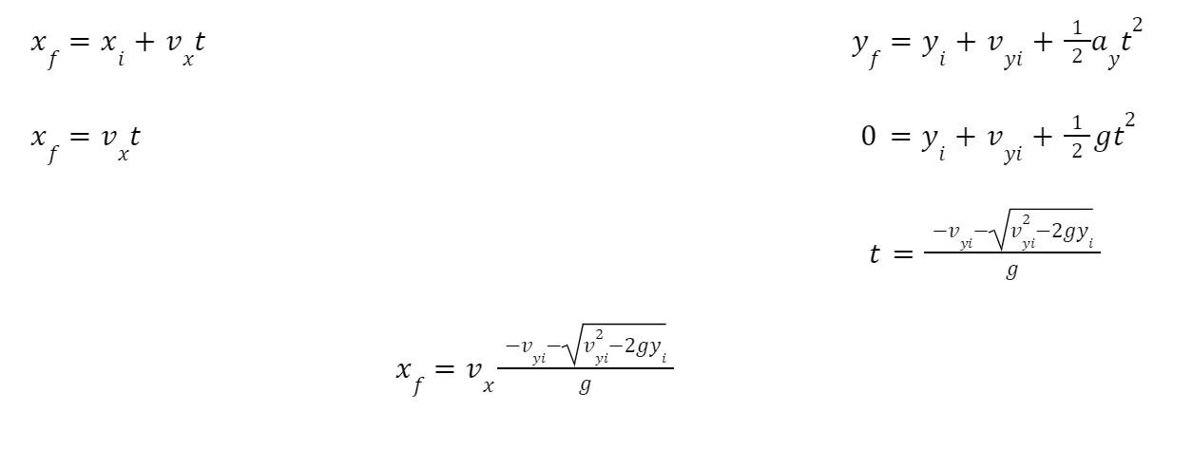

**Animation**



This animation was created by “shooting” an arrow at 40 degrees with a speed of

10 m/s with an initial height of 2 meters.

I used the python package *Matplotlib* in order to animate and display the path of the arrow. I additionally used the python package *Numpy* in order to perform some of the numerical calculations.

**Time Log**

10-31-22 0.5 hours Brainstorming/researching ideas

10-31-22 2 hours Researching and learning python libraries/planning program

11-17-22 2 hours Writing and working on coding program

11-18-22 1.5 hours Testing and finalizing program

11-18-22 1 hour Attempting to learn LaTeX and failing to do so

11-18-22 1 hour Writing and submitting write-up

Total: 8 hours